[**Milestone 3**](https://bblearn.griffith.edu.au/webapps/assignment/uploadAssignment?content_id=_2172496_1&course_id=_48251_1&assign_group_id=&mode=view)

**Milestone 3 - Persistence and Deletion**

***Xcode Project and Git Repository***

For this milestone, you can keep using last week's **MyPhotos** Xcode project.  Commit every step described below to the git repository!   Also make sure you have a meaningful description for every commit that outlines the changes you made since the last commit (another reason to commit often as this makes it less likely to forget the details of all your changes!).

***Testing***

Create *unit tests* for your model making sure that you follow a tests-first approach (you need to **commit your tests to git before the model is implemented to demonstrate this**)!  In addition to the tests from last week, make sure you test the code for *loading* and *saving* (model persistence) below!

Create *user interface tests* for your view (and view controller) that tests the added functionality for this milestone (there is no need to create the user interface tests before your model implementation, this is only required for the unit tests above).

***Model: Persistence***

[*Read the Property List Programming Guide*](https://developer.apple.com/library/mac/#documentation/Cocoa/Conceptual/PropertyLists/Introduction/Introduction.html#//apple_ref/doc/uid/10000048i)*in the Developer Documentation!*  Make sure your model data (but *not* the actual image data downloaded from the web) are saved (every time a change is made to the data in the array) to a file called "photos.plist" in your application's user documents directory.  Load the data back in (if they exist) when your program starts!

If you prefer, you can read and write the data in JSON format (as "photos.json") instead of using property lists!

***Detail View: Delete Button and Alert View Action Sheet***

For this milestone, the master view stays unchanged.  Edit your main story board's **detail** view to include a delete button (red bin icon) in the top right corner.  Once the delete button is pressed, an action sheet alert view should pop up at the bottom to confirm the delete action (make sure the text includes the title of the image -- see screenshots below).  When the delete action is confirmed, return to the master view, deleting the image from the the collection of photos.  Here is an image of what your detail view user interface (first without, then with the delecte action alert view) should look like:

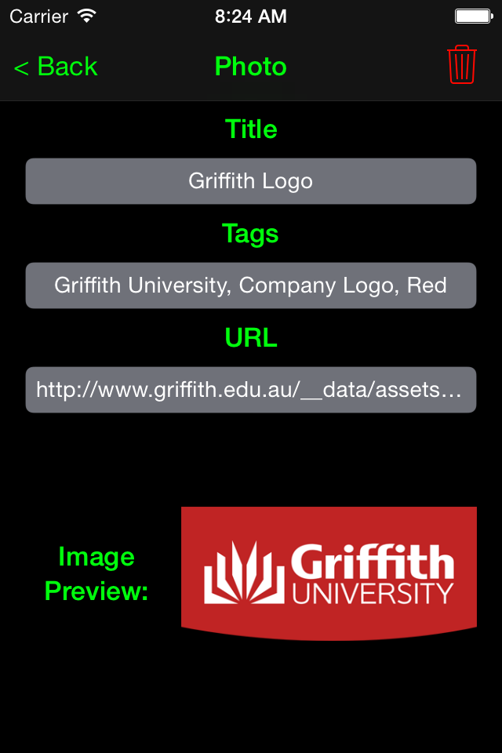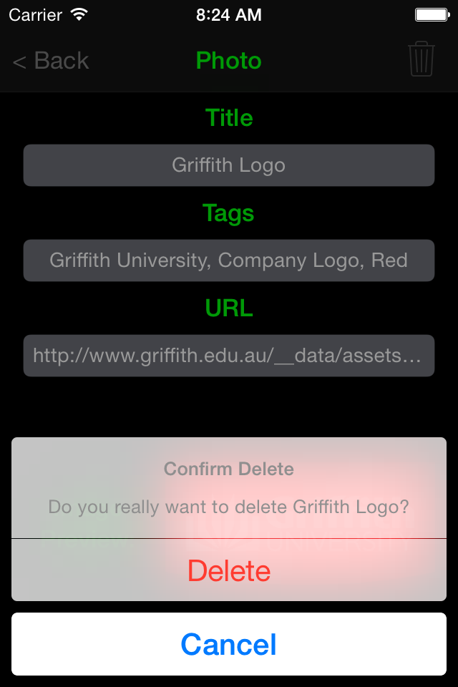

Make sure you link up the necessary actions and outlets!

***General Style***

Use best practices when writing your code.  E.g., use subclassing, delegation, and other object-oriented design patterns as appropriate.  Make sure all your source files (.swift files) have a comment header that contains your name as the author and your student ID.  Put swiftdoc-style comments in front of your classes, properties, and methods (including test methods), describing what each of these do!  For methods, make sure you document parameters and return types as well as pre- and post-conditions!  Make sure your code is well formatted and readable, and uses consistent indentation!

***Submission***

Zip up the folder that contains your project (e.g. if your project is called MyPhotos, you should find a *MyPhotos* folder on the Desktop). On the Mac, you can easily create a ZIP file of a folder by holding the Control key, clicking on the folder you want to zip up, and then select Compress "MyPhotos" to compress).  Submit the ZIP file to BBlearn (click on the link that reads Milestone 3 at the top of this milestone page, then attach your ZIP file, and submit).